Ofir Nesher - 204502926

Chen Arnon - 304843188

**Exercise 3:**

Class Program:

* All the user interface implementation.
* Validate all inputs by user.

Class GarageManager:

* All logic of 7 requested functions.

Class VehicleMaker:

* Create a vehicle according to given vehicle type
* Using the constructor of wanted vehicle with a given list of data.

Abstract Class Vehicle:

* Sets and gets relevant attributes and methods of vehicle.

Abstract Class ElectricVehicle:

* Inherits from Vehicle.
* Sets and gets relevant attributes and methods of electric vehicle.

Class ElectricBike:

* Inherits from ElectricVehicle.
* Sets and gets relevant attributes and methods of electric bike.

Class ElectricCar:

* Inherits from ElectircVehicle.
* Sets and gets relevant attributes and methods of electric car.

Abstract Class FuelVehicle:

* Inherits from Vehicle.
* Sets and gets relevant attributes and methods of fuel vehicle.

Class FuelBike:

* Inherits from FuelVehicle.
* Sets and gets relevant attributes and methods of fuel bike.

Class FuelCar:

* Inherits from FuelVehicle.
* Sets and gets relevant attributes and methods of fuel car.

Class Truck:

* Inherits from FuelVehicle.
* Sets and gets relevant attributes and methods of truck.

Class VehicleInfo:

* Hold list containing relevant info of vehicle - Owner name, number and vehicle status.

Class Wheel:

* Sets and gets relevant attributes and methods (fill air) of a wheel.
* Function of inflating wheel pressure.

Enum eCarColor:

* 4 options enum of the car colors

Enum eEnergyType:

* 5 options enum of the energy types (soler/electric/octan96/95/98)

Enum eLicenseType:

* 4 options enum of bike license types (A/AB/A2/B1).

Enum eMainMenu:

* 8 options enum of the functionality of the garage system (the 7 main methods and ToQuit).

Enum eNumOfDoors:

* 4 options enum of number of doors of a car (2/3/4/5).

Enum eVehicleStatus:

* 4 options enum (fixed, in progress, payed, other) of vehicle status in garage.

Enum eVehicleType

* 5 options enum of type of vehicles (leaf nodes in diagram).

Exception ValueOutOfRangeException:

* Inherits from Exception.
* Thrown in case of not compatible input in sense of relevant range of values.

**Classes Diagram:**

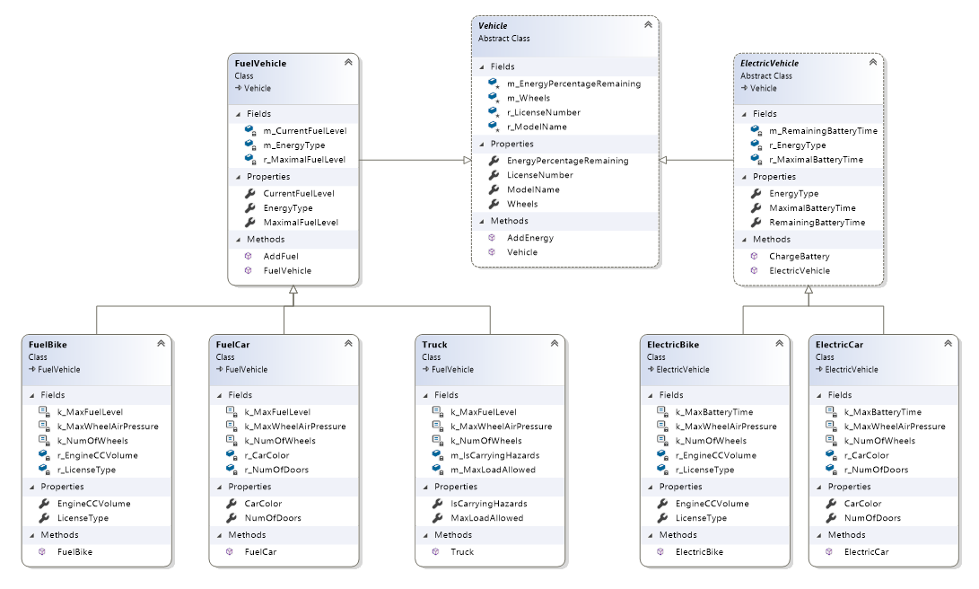

**Other Components: enums:**

